Cable Change Instructions

- Take the boat off the lift. Raise the lift and place walkboards across the slip. Let the cradles down to rest on the boards. This should create slack in the cables.

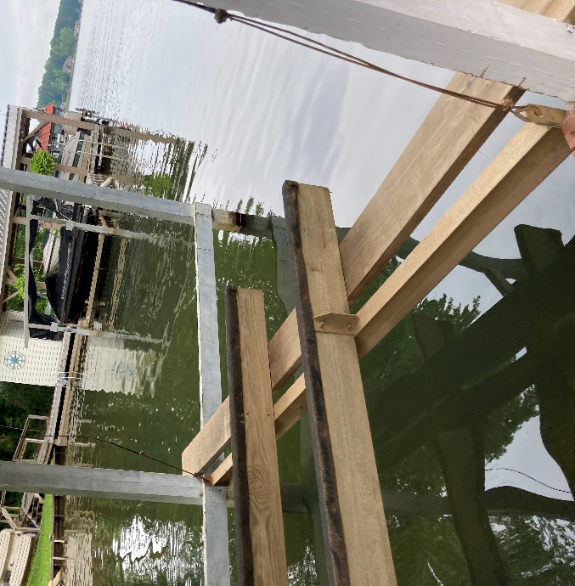

- Cut the out cables and unwind. Cut off/remove the old thimbles

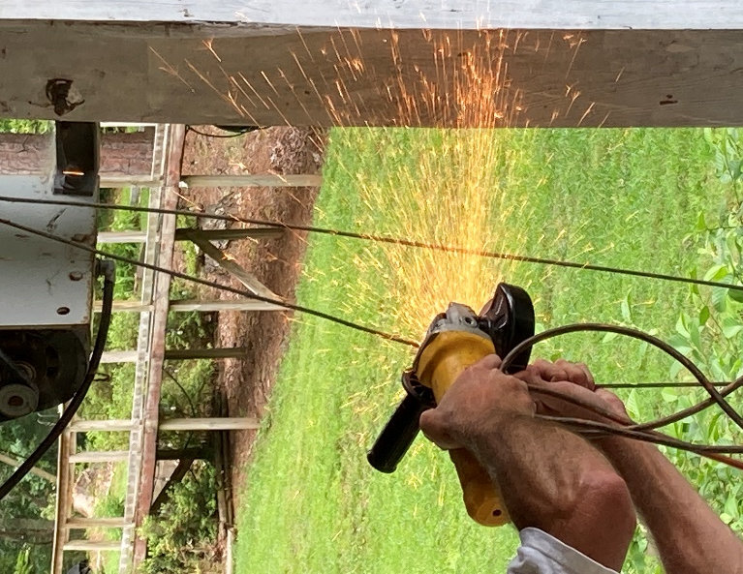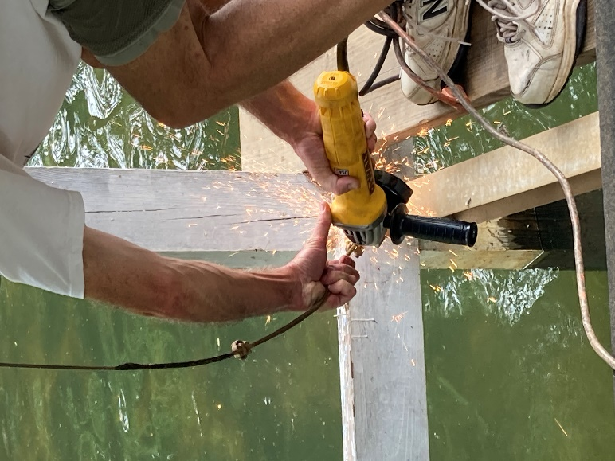

- Measure and mark the middle of the new cables.

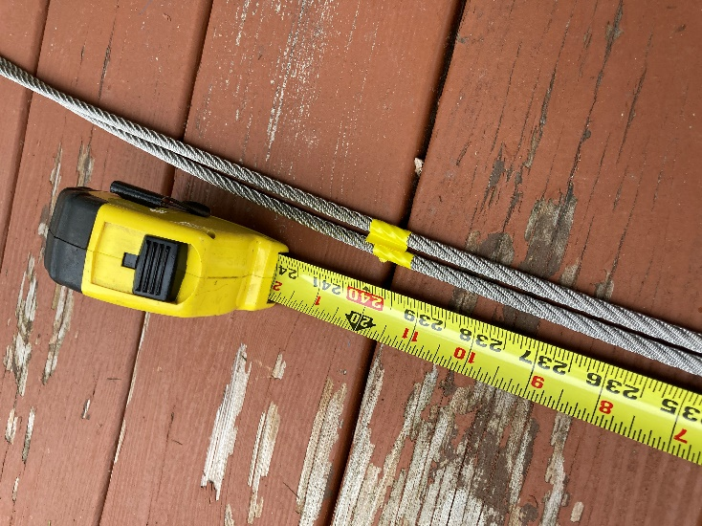

- Run cables through pipe and pulleys. Put new thimbles on. Shackles are extra but can be bought to help place thimbles on cradle easier (see picture instruction for step 6) .

- Pull the mark (the middle of the cable) until it’s in the middle of the lift.
- Run ends through the cradle ends and turn up about 2 feet and clamp with two clamps, but don’t overtighten. There will be a live wire and a dead wire. The dead wire is the 2 feet extra and the live wire is carrying the load. When attaching clamps, the nuts should be on the live side of the wire.
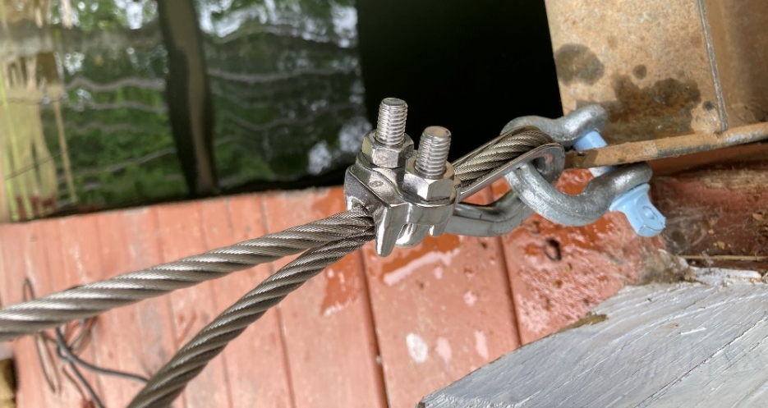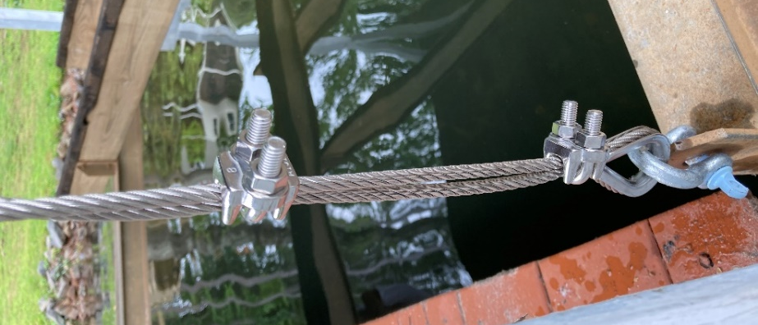

- Slide the cradles off the board into the water. Operate the lift to wind the cables up on the pipe, making sure the cables wind neatly. To make cables wind neatly, start winding the lift up 1 ¼ turn, stop. Look to make sure they are not over lapping. Fix and continue winding.
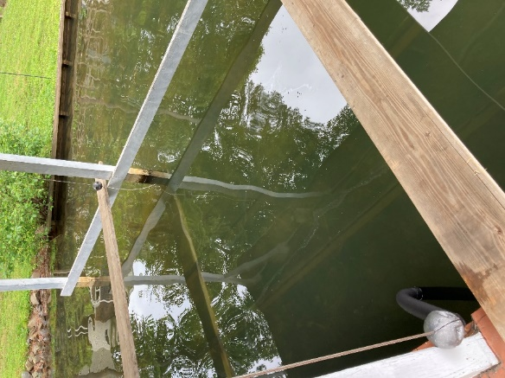

- Place the boards across the slip again and adjust the cradles by loosing the clamps and pulling the wire to the desired length. Typically you want the front cradle 4” higher for a v-hull style boat. For a pontoon you can have it level if you prefer.

- When the cradles are level, tighten the clamps securely. Do NOT overtighten, it will strip the thread.

- Put black electrical tape over the end of the dead and live wire.

